Chapter 1: Review Questions
- Describe the historic development of Internet and smartphone technology from the early days of personal computers (PCs) to today’s Internet Web application and smartphone app–based information systems environment.
The Web and Web browsers became available in the early 90’s. In the early 2000’s, Web sites starting allowing user to add personal content and data (e.g., images and video) which previously only displayed static content. About this same time cell phones developed into a digital platform capable of transmitting data and connecting to the Web. Most of what people do with websites and smartphones depends upon databases. (Page 5).
- Why do today’s Internet Web applications and smartphone apps need databases?
- Most online activities depend on databases. For example, when you post on Facebook or tweet on Twitter, that data is stored in a database before being displayed.
- Shopping sites like Amazon rely on databases to search and return results when you type keywords.
- IoT devices (like smart speakers and home devices) also depend on apps and services that are powered by databases.
- Even local businesses like grocery stores and coffee shops use point-of-sale (POS) systems that record transactions in databases for tracking inventory and customer purchases.
In short: without databases, the modern Web, smartphone apps, and IoT services
would not function as they do today. (Page 5-8)
- Read the description of the search process on the Pearson Web site in this chapter. Using your own computer, find another retailer Web site (other than those discussed or mentioned in this chapter), and search for something of interest to you. Write up a description (with screen shots if possible) of your search.
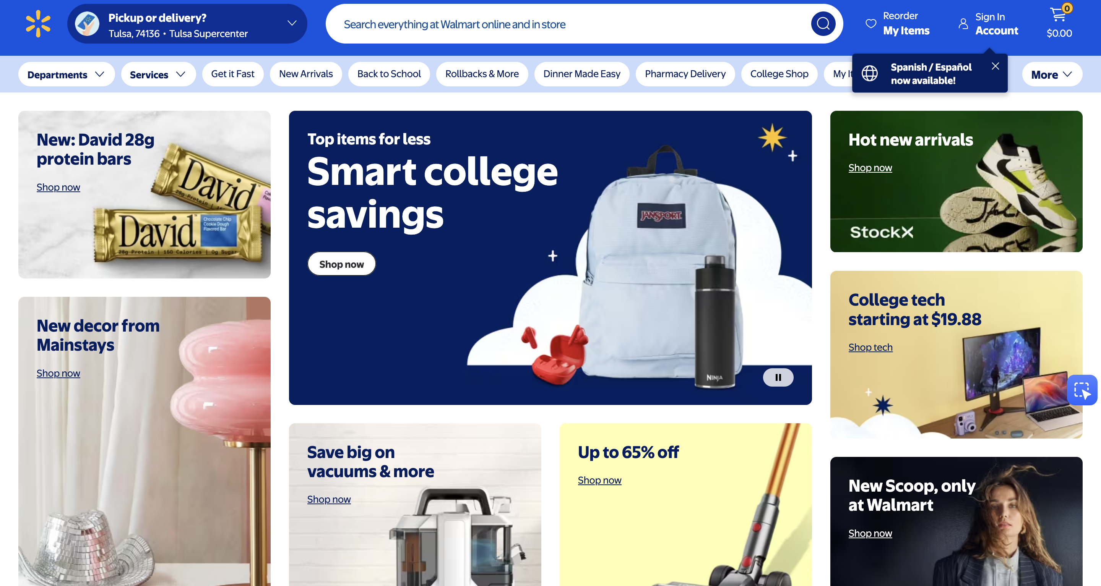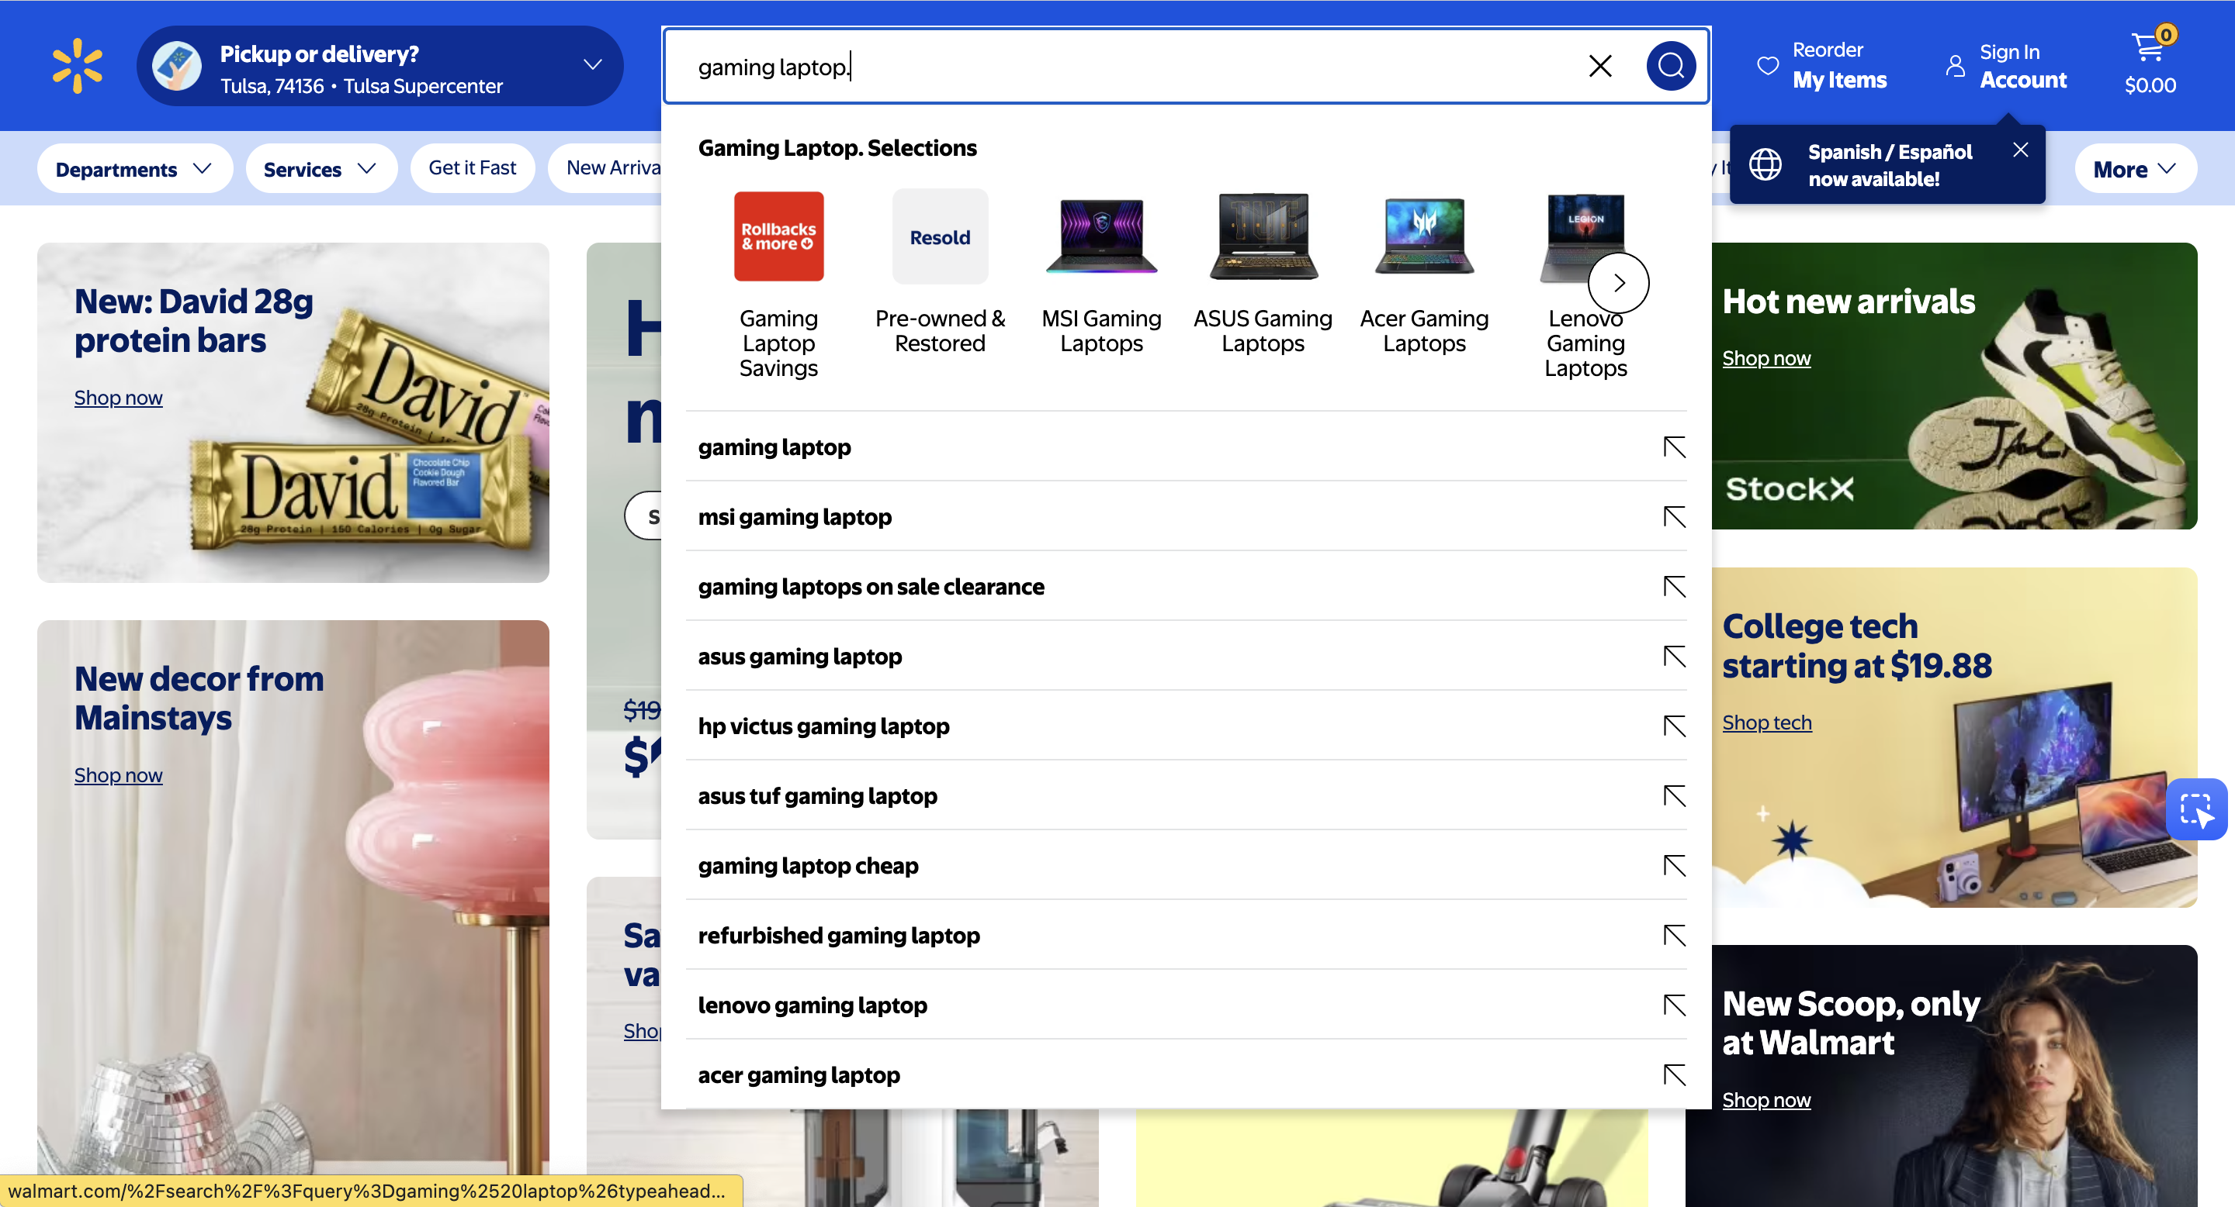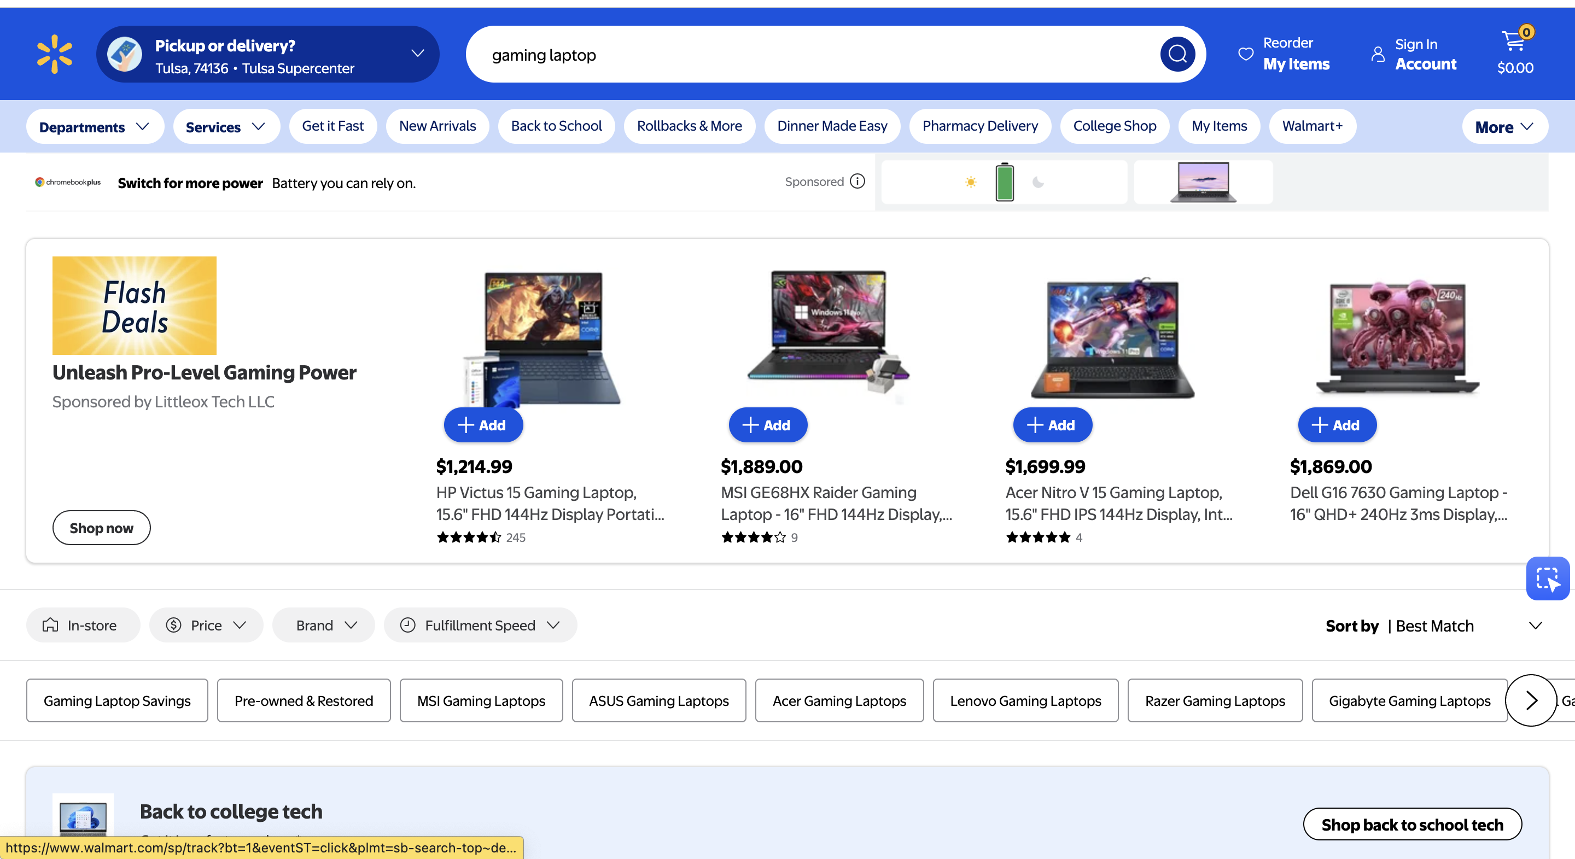
I went to Walmart.com and used the search bar on the home page to look for “gaming laptop.” After entering the keyword and clicking the search button, Walmart’s system searched its product database and displayed a results page with multiple gaming laptops, including their prices, images, and specifications. Each item shown is stored in Walmart’s database and retrieved when a user performs a search.

- Why is the study of database technology important?
The study of database technology is important because databases are the main way we keep track of information in today’s digital world. Unlike simple spreadsheets, which can lead to errors and inconsistencies, databases organize data into structured tables that can be shared reliably. Since modern apps, websites, and even IoT devices all depend on databases, learning how they work is essential. In short, database technology provides the foundation for accurate and consistent data management across everyday life and business. (Page 10)
- What is the purpose of this book?
The purpose of this book is to introduce the fundamental concepts and techniques of database management. In Part 1, it explains database technology, why databases are used, the components of a database system, and introduces cloud computing and virtualization. Chapter 2 covers the relational model and key relational database terms, along with basic design principles, while Chapter 3 presents SQL as the international standard for creating and processing relational databases. After these fundamentals, Part 2 focuses on database modeling, design, and implementation. Finally, Part 3 discusses database management, data warehouses, business intelligence systems, cloud computing, virtualization, Big Data, and NoSQL database management systems.(Page 1)
- Describe the purpose of a database.
The purpose of a database is to help people keep track of things in an organized and reliable way. The most common type is the relational database, although nonrelational databases are also widely used today in applications like Facebook and Twitter. Unlike simple lists or spreadsheets, which often lead to errors, inconsistencies, and scattered data, a database organizes information into structured tables that can be shared and used by multiple people within an organization. This structure reduces problems and ensures that data is accurate, consistent, and accessible. (Page 9)

- What is a modification problem? What are the three possible types of modification problems?
A modification problem occurs when data is stored in lists or poorly designed tables, causing errors or inconsistencies when changes are made. The three possible types are:
Insert problem – difficulty adding new data without causing errors.
- Update problem – changes to data may not be applied consistently everywhere.
- Delete problem – removing data may unintentionally remove important related information.

- Figure 1-42 shows a list that is used by a veterinary office. Describe three modification problems that are likely to occur when using this list.
Duplicate entries: Due to human error or system glitches, it is possible for the same item to be entered multiple times in the list. This can lead to confusion and inefficiency when trying to locate specific information or perform tasks related to those entries.
Outdated information: Over time, the list may become outdated as new information becomes available or existing information changes. For example, contact details of clients or patients may change, and if not updated in the list, it can result in communication issues or incorrect records.
Incomplete or missing entries: It is possible for certain entries to be incomplete or missing altogether. This can occur if the person responsible for maintaining the list forgets to include all the necessary information or accidentally skips certain entries. Incomplete or missing entries can hinder the smooth functioning of the veterinary office and may lead to errors in patient care or billing.
These modification problems can impact the accuracy, efficiency, and overall effectiveness of the list used by the veterinary office. Regular review, verification, and updating of the list can help mitigate these issues and ensure the smooth operation of the office.

- Name the two themes in the list in Figure 1-42.
Pet Information and Owner Information

- What is an ID column?
A column used as primary key that usually has surrogate key values (Page 564)

1.11 Break the list in Figure 1-42 into two tables, each with data for a single theme. Assume that owners have a unique phone number but that pets have no unique column. Create an ID column for pets like the one created for customers and courses for the Art Course database tables in Figure 1-12.
Owner Table
Schema: Owner(OwnerLastName, OwnerFirstName, OwnerEmail, OwnerPhone)
Description: This table stores owner details like first and last name, phone number, and email.
FD: OwnerEmail ==> OwnerLastName, OwnerFirstName, OwnerPhone.
OwnerLastName | OwnerFirstName | OwnerEmail | OwnerPhone
Downs | Marsha | Marsha.Downs@somewhere.com | 201-823-5467
James | Richard | Richard.James@somewhere.com | 201-735-9812
Frier | Liz | Liz.Frier@smewhere.com | 201-823-6578
Trent | Miles | Miles.Trent@somewhere.com | 201-634-7865
Evans | Hilary | Hilary.Evans@somewhere.com | 201-634-2345

Pet Table
Schema: Pet(PetName, PetType, PetDOB, PetBreed)
Description: This table stores pet details like name, DOB, type, and breed.
FD: PetName ==> PetType, PetBreed, PetDOB.
PetName | PetType | PetDOB | PetBreed
King | Dog | 27-Feb-14 | Std.Poodle
Teddy | Cat | 1-Feb-13 | Cashmier
Fido | Dog | 17-Jul-15 | Std.Poodle
AJ | Dog | 5-May-15 | Collie Mix
Cedro | Cat | 6-Jun-12 | Unknown
Woolley | Cat | null | Unknown
Buster | Dog | 11-Dec-11 | Border Collie
Jiddah | Cat | 1-Jul-08 | Abyssinian

Pet Owner Table
Schema: PetOwner(PetName, OwnerEmail)
Description: This table stores pet and owner details.
PetName | OwnerEmail
King | Marsha.Downs@somewhere.com
Teddy | Richard.James@somewhere.com
Fido | Marsha.Downs@somewhere.com
AJ | Liz.Frier@smewhere.com
Cedro | Richard.James@somewhere.com
Woolley | Richard.James@somewhere.com
Buster | Miles.Trent@somewhere.com
Jiddah | Hilary.Evans@somewhere.com

- Show how the tables you created for question 1.11 solve the problems you described in question 1.8.
1. Eliminating redundancy:- In the original list, the owner's name and phone number were repeated for each pet. In the new tables, this information is only stored once, in the Owner table. This eliminates the possibility of errors caused by typing the same information multiple times.
2.Ensuring data integrity. In the original list, there was no way to ensure that the data was accurate. For example, there was no way to prevent someone from adding a pet to the list without also adding an owner for that pet. In the new tables, the Pet table has a foreign key that references the Owner table. This ensures that every pet has a corresponding owner, and that the owner information is always up to date.
3.Making the data easier to query. In the original list, it was difficult to query the data for specific information. For example, if you wanted to find all the pets that had been seen by a particular veterinarian, you would have to manually search through the list. In the new tables, it is much easier to query the data. For example, you can use a SQL query to find all the pets that have been seen by a particular veterinarian.
- What does SQL stand for, and what purpose does it serve?
Standard Query Language (SQL) , SQL is used for combining, and processing sets of tables. Also, it used for data definition and manipulation.(Page 16)

- Another version of the list used by the veterinary office is shown in Figure 1-43. How many themes does this list have? What are they?
* Pet
* Owner
* Service

1.15 Break the list in Figure 1-43 into tables, each with a single theme. Create ID columns as you think necessary.
Pet
PET ID | Pet Name | Pet type | Pet Breed | Pet DOB | Owner phone
PK |  |  |  |  | FK

Owner
Owner phone | Owner firstname | Owner lastname | Owner email
PK

Service
Service ID | Service | Date | Change | PetID
PK |  |  |  | FK

PK- Primary Key
FK – Foreign key

- Show how the tables you created for question 1.15 solve the three problems of lists identified in this chapter.
I split the list into three tables on the basis of “normalization”, which solves our three problems of insertion, Update, and Deletion.
To address these issues, relations with redundant data are decomposed into smaller and well-structured ones through a process called normalization. Normalization eliminates problems such as insertion, update, and deletion anomalies, ensuring data is consistent and efficient to manage.

- Describe in your own words and illustrate with tables how relationships are represented in a relational database.
Relationships are represented by storing the key values of one table, such as PetID or OwnerPhone, in a column in a second table to serve as a linking value. In the SERVICE table, for example, the value of PetID means that the service was performed for that particular pet, which links to the PET table.

- Name the four components of a database system.
1. User
2. The database application
3. The database management system (DBMS)
4. The database (Page 17)
- Define the term database.
A database is defined as a self-describing collection of related records (Page 17)

- Why do you think it is important for a database to be self-describing?
Self-describing means that a description of the structure of the database is contained within the database itself, because this is so, the contents of a database can always be determined just by looking inside the database itself. (Page 17)

- List the contents of a database.
1. User data
2. Metadata
3. Indexes and other overhead data
4. Application metadata (Page 18)
- Define the term metadata, and give some examples of metadata.
Metadata can be defined as data about the structure of a database. Examples of metadata are the names of Tables, the name of columns and the tables to which they belong, properties of tables and columns, and so forth (Page 17)
- Describe the use of an index.
It is an example of a supporting structure that is created and maintained by a DBMS (Page 19)

- Define the term application metadata, and give some examples of application metadata.
Application metadata can be described as data with application elements such as forms and reports. For example, Microsoft Access. (Page 18)
1.25 What is the purpose of a DBMS?
The purpose of a DBMS is to create, process, and administer databases (Page 19)

