Chapter 3 Review Questions & SQL Code

- What does SQL stand for?
Structured Query Language (Page 151).

- What is a data sublanguage?
Data sublanguage: A language for defining and processing a database intended to be embedded in programs written in another language—in most cases, a procedural language such as PHP, C#, or Visual Basic. A data sublanguage is an incomplete programming language because it contains only constructs for data definition and processing.(page 562)

- Explain the importance of SQL-92.
SQL 92 national standard that is the basis for commercial DBMS products today, and it contains the basic set of standard SQL contained in later versions of the SQL standard.(page 151)

- Why is it important to learn SQL?
1) Easy to understand - SQL makes data easy to understand with high efficiency. It helps the device to understand the data and simplify it.
2) It is easy to learn - SQL can be learned easily. He can be used with simple queries that can help to access data and manage it.
3) Data mining - SQL helps in data mining. It helps you to get data easily. You can set data or programs according to your need and get data at regular intervals.
4) Easier data manipulation - It is easy to manipulate data with SQL. It contains dynamic data. You can access it anytime and manipulate it.

- Describe in your own words the purpose of the two business rules listed on page 158.
The first rule protects ongoing work by preventing employee deletions unless assignments are handled.
The second rule prevents irrelevant data from lingering by cleaning up assignments tied to canceled projects.
- Why do some standard SQL-92 statements fail to run successfully in Microsoft Access?
The current standard version of SQL is ANSI SQL-92 (which Microsoft refers to as ANSI-92 SQL). However, by default, Microsoft Access uses an earlier version of the ANSI standard—Microsoft calls it ANSI-89 SQL or Microsoft Jet SQL (after the Microsoft Jet DBMS used by Microsoft Access). ANSI-89 SQL differs significantly from SQL-92, and, therefore, some features of the SQL-92 language will not work in Microsoft Access.

When you run a query in a Microsoft Access database that joins linked Microsoft SQL Server tables from different sources or databases, the query may not return any data.(Page 158)

Use the following tables for your answers to questions 3.7 through 3.48:
PET_OWNER (OwnerID, OwnerLastName, OwnerFirstName, OwnerPhone, OwnerEmail)
PET (PetID, PetName, PetType, PetBreed, PetDOB, OwnerID)
Sample data for these tables are shown in Figures 3-27 and 3-28. For each SQL statement you write, show the results based on these data. If possible, run the statements you write for the questions that follow in an actual DBMS, as appropriate, to obtain results. Use data types that are consistent with the DBMS you are using. If you are not using an actual DBMS, consistently represent data types by using either the MySQL, Microsoft SQL Server, or Oracle Database data types shown in Figure 3-5.
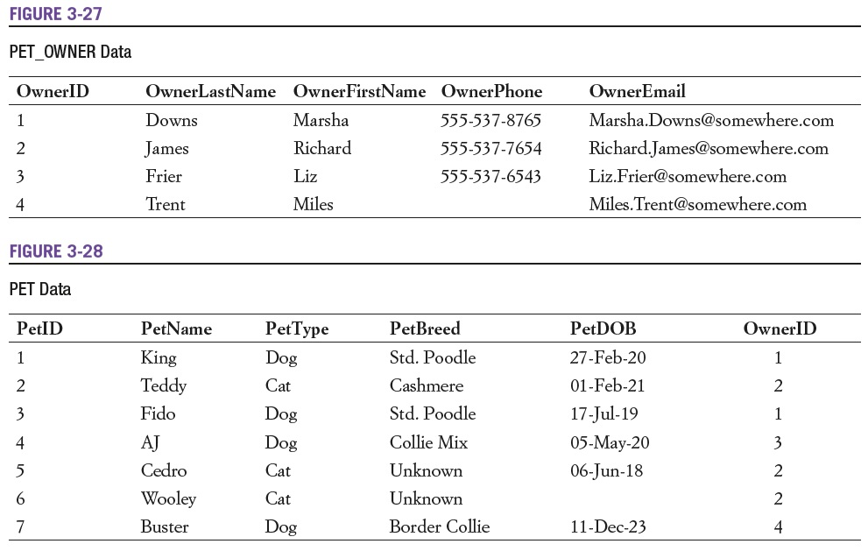

- Write an SQL CREATE TABLE statement to create the PET_OWNER table, with OwnerID as a surrogate key. Justify your choices of column properties. If you are using an actual DBMS, also insert the data using SQL.
create table PET_OWNER (OwnerID INTEGER AUTO_INCREMENT PRIMARY KEY,OwnerLastName CHAR(10),OwnerFirstName CHAR(10),OwnerPhone VARCHAR(15),OwnerEmail VARCHAR(30));

- Write an SQL CREATE TABLE statement to create the PET table without a referential integrity constraint on OwnerID in PET. Justify your choices of column properties. Why not make every column NOT NULL? If you are using an actual DBMS, also insert the data using SQL.
create table PET(PetID integer primary key, PetName char(10),PetType char(5),PetBreed varchar(20),PetDOB varchar(15),OwnerID integer);
Why not make every column NOT NULL?
Because in PetDOB Column there is no value so we considered that as NULL value.

- Create a referential integrity constraint on OwnerID in PET. Assume that deletions should not cascade.
ALTER TABLE PET ADD FOREIGN KEY (OwnerID) REFERENCES PET_OWNER (OwnerID);

- Create a referential integrity constraint on OwnerID in PET. Assume that deletions should cascade.
ALTER TABLE PET ADD FOREIGN KEY (OwnerID) REFERENCES PET_OWNER (OwnerID) ON DELETE CASCADE;

The following table schema for the PET_2 table is an alternate version of the PET table- use it to answer review questions 3.11 and 3.12:
PET_2 (PetName, PetType, PetBreed, PetDOB, OwnerID)

- Write the required SQL statements to create the PET_2 table.
create table PET_2 (Pet_Name char(20) primary key,PetType char(5),PetBreed varchar(20),PetDOB varchar(15),OwnerID integer references PET_OWNER (OwnerID));

- Is PET or PET_2 a better design? Explain your rationale.
PET table is a better design. because it have more information

- Write the SQL statements necessary to remove the PET_OWNER table from the database. Assume that the referential integrity constraint is to be removed. Do not run these commands in an actual database!
ALTER TABLE PET DROP FOREIGN KEY fk_pet_owner; -- or fk_pet_owner_cascade
DROP TABLE PET_OWNER;

- Write the SQL statements necessary to remove the PET_OWNER table from the database. Assume that the PET table is to be removed. Do not run these commands in an actual database!
DROP TABLE PET; -- drop child first
DROP TABLE PET_OWNER; -- then parent

- Write an SQL statement to display all columns of all rows of PET. Do not use the asterisk (*) notation.
SELECT PetID, PetName, PetType, PetBreed, PetDOB, OwnerID
FROM PET;

- Write an SQL statement to display all columns of all rows of PET. Use the asterisk (*) notation.
SELECT * FROM PET;

- Write an SQL statement to display the breed and type of all pets.
SELECT PetBreed, PetType FROM PET;

- Write an SQL statement to display the breed, type, and DOB of all pets having the type Dog.
SELECT PetBreed, PetType, PetDOB
FROM PET
WHERE PetType = 'Dog';

- Write an SQL statement to display the PetBreed column of PET.
SELECT PetBreed FROM PET;

- Write an SQL statement to display the PetBreed column of PET. Do not show duplicates.
SELECT DISTINCT PetBreed FROM PET;

- Write an SQL statement to display the breed, type, and DOB for all pets having the type Dog and the breed Std. Poodle.
SELECT PetBreed, PetType, PetDOB
FROM PET
WHERE PetType='Dog' AND PetBreed='Std. Poodle';

- Write an SQL statement to display the name, breed, and type for all pets that are not of type Cat, Dog, or Fish.
SELECT PetName, PetBreed, PetType
FROM PET
WHERE PetType NOT IN ('Cat','Dog','Fish');

- Write an SQL statement to display the Pet ID, breed, and type for all pets having a four-character name starting with K. Note that the RTRIM function will be needed in the solution that uses a CHAR column, but not for one that uses a VARCHAR column.
SELECT PetID, PetBreed, PetType
FROM PET
WHERE PetName LIKE 'K___';

- Write an SQL statement to display the last name, first name, and email of all owners who have an email address ending with somewhere.com. Assume that email account names can be any number of characters. Note that the RTRIM function will be needed in the solution that uses a CHAR column, but not for one that uses a VARCHAR column.
SELECT OwnerLastName, OwnerFirstName, OwnerEmail
FROM PET_OWNER
WHERE OwnerEmail LIKE '%@somewhere.com';

- Write an SQL statement to display the last name, first name and email of any owner who has a NULL value for OwnerPhone.
SELECT OwnerLastName, OwnerFirstName, OwnerEmail
FROM PET_OWNER
WHERE OwnerPhone IS NULL;

SQL (Structured Query Language) Code

After finishing the hands-on portion of Assignment 3, copy and paste your
SQL (Structured Query Language) code below.

1. SQL code to retrieve “All Customers” in the “CUSTOMER” table.
SELECT CustomerID, LastName, FirstName, Address, City, State, Zip, [Email Address] FROM CUSTOMER;

2. SQL code to retrieve all customers from “Oklahoma” in the “CUSTOMER” table.
SELECT CUSTOMER.LastName, CUSTOMER.FirstName, CUSTOMER.Address, CUSTOMER.City, CUSTOMER.City, CUSTOMER.State, CUSTOMER.Zip from CUSTOMER
WHERE (((CUSTOMER.State)=”OK”));

3. SQL code to retrieve all customers from “Tulsa” in the “CUSTOMER” table.
SELECT CUSTOMER.LastName, CUSTOMER.FirstName, CUSTOMER.Address, CUSTOMER.City, CUSTOMER.City, CUSTOMER.State, CUSTOMER.Zip, CUSTOMER.[Email Address] from CUSTOMER
WHERE (((CUSTOMER.State)=”Tulsa”));

4. SQL code created to retrieve all “phone” contacts using a “JOIN” operation with the “CUSTOMER” and “CONTACT” table.
SELECT CUSTOMER.LastName, CUSTOMER.FirstName, CONTACTS.ContactDate, CONTACTS.ContactType, CONTACTS.Remarks, from CUSTOMER INNER JOIN CONTACTS ON CUSTOMER.Customer.ID = CONTACTS.ContactID
WHERE (((CONTACTS.ContactsDate)>=”Phone”));

5. SQL code created to retrieve all contacts created since January 1, 2024 using a “JOIN” operation with the “CUSTOMER” and “CONTACT” table.

SELECT CUSTOMER.LastName, CUSTOMER.FirstName, CONTACTS.ContactDate, CONTACTS.ContactType, CONTACTS.Remarks, from CUSTOMER INNER JOIN CONTACTS ON CUSTOMER.Customer.ID = CONTACTS.ContactID
WHERE (((CONTACTS.ContactsDate)>=#1/1/2024#));

