Name: Type Your Name Here

Final Exam

Business Database Management Systems

MULTIPLE CHOICE. (40 Questions) Choose the one alternative that best completes the statement or answers the question. Enter your answer in the table below.

1. E | 11. A | 21. A | 31. B
2. A | 12. A | 22. B | 32. C
3. B | 13. C | 23. B | 33. A
4. E | 14. B | 24. C | 34. D
5. E | 15. A | 25. A | 35. B
6. E | 16. C | 26. E | 36. D
7. E | 17. D | 27. D | 37. D
8. B | 18. B | 28. E | 38. D
9. D | 19. B | 29. B | 39. D
10. C | 20. A | 30. D | 40. E

1) What role does the Web browser play in a Web database application?
A) Microchip accelerator
B) Back-end Database Management System
C) Bug-reporting System
D) Hardware support
E) Web user interface

2) A relational database is .
A) a self-describing collection of related tables
B) a set of metadata
C) a set of applications and the data sets for those applications
D) a library of queries and data files for querying
E) a collection of forms and reports that support a given purpose

3) The creation of a database and its tables is a function of which component of the database system?
A) Web server
B) DBMS
C) Database
D) Application
E) Users

4) A relational database stores data in the form of .
A) columns
B) lists
C) spreadsheets
D) forms
E) tables

5) Microsoft Access 2019 database files are stored using the file extension .
A) .mdb
B) .asp
C) .sql
D) .adb
E) .accdb

6) The Microsoft Access 2019 data type of AutoNumber is used when there is a specific need for a .
A) primary key
B) secondary key
C) spare key
D) foreign key
E) surrogate key

7) Which of the following problems associated with storing data in a list is avoided by storing data in a relational database?
A) Lack of necessary bandwidth
B) Running out of memory storage
C) Incorrect data typing
D) CPU processing inefficiencies
E) Duplication of data items

8) Which of the following terms is synonymous with "tuple"?
A) Attribute
B) Row
C) Relation
D) Table
E) Field

9) Which of the following is true about a key?
A) It may be unique.
B) It may be nonunique.
C) It can only identify one row.
D) Both A and B
E) None of the above

10) A key that contains more than one attribute is called a(n) .
A) multi-key
B) n-key
C) composite key
D) candidate key
E) complex key

11) A primary key is .
A) a candidate key
B) used to represent columns in relationships
C) comprised of exactly one attribute
D) not required to be unique
E) always automatically generated by the DBMS

12) Given the below functional dependency,

MedicineCode → (MedicineName, ShelfLife, Manufacturer, Dosage)

which of the following statements is not known to be true?
A) MedicineName is a determinant.
B) MedicineCode is a candidate key of the relation MEDICINE (MedicineName, ShelfLife, Manufacturer, Dosage).
C) MedicineCode is a determinant.
D) Manufacturer is functionally dependent on MedicineCode.
E) ShelfLife is functionally dependent on MedicineCode.

13) Which of the following functional dependency diagrams accurately represents the following situation:
• A campus has many buildings.
• Each building has a unique name.
• Each building has many rooms.
• All rooms in any given building are numbered sequentially starting at "101."
• Each room has a certain capacity, although many rooms in the same building or different buildings may have the same capacity.
• Each room is assigned to a single department.
• A department may have many rooms in one or more buildings, each with the same or different capacities.
13 Answer:
A) (Department, Capacity) → (BuildingName, RoomNumber)
B) BuildingName → (RoomNumber, Capacity, Department)
C) (BuildingName, RoomNumber) → (Capacity, Department)
D) RoomNumber → (BuildingName, Department, Capacity)
E) (BuildingName, Capacity) → (Department, RoomNumber)

14) When the primary key of one relation is placed into a second relation, it is called a .
A) candidate key
B) foreign key
C) relocated key
D) referential integrity
E) field key

15) Given the relations:

STUDENT (SID, StudentName, Major, AdvisorID) ADVISOR (AdvisorID, AdvisorName, Office, Phone)

such that each student is assigned to one advisor, which of the following is true?
A) AdvisorID is a foreign key.
B) SID is both a primary key and a foreign key.
C) Major is a candidate key.
D) Phone is a candidate key.
E) AdvisorName is a determinant.

16) Which of the following is true about a relation?
A) The order of the columns in a relation must go from largest to smallest.
B) A relation may have multiple names.
C) All entries in any column must be of the same kind.
D) A relation may have duplicate rows.
E) A relation may have duplicate column names.

17) The order of the columns returned by an SQL SELECT statement is determined by the .
A) SORT BY clause
B) ORDER BY clause
C) order they are listed in following WHERE
D) order they are listed in following SELECT
E) order they are listed in following FROM

18) Which of the following is the correct SQL clause to restrict the results of a SELECT query to only records that have a value in the range of 10 to 50 in the Hours column?
A) WHERE Hours IN [10, 50]
B) WHERE Hours BETWEEN 10 AND 50
C) WHERE Hours = MIN(10) and MAX(50)
D) WHERE Hours = 10 and Hours = 50
E) WHERE Hours RANGE 10 TO 50
19) Which SQL keyword can be used in conjunction with wildcards to select partial values?
A) SUBSTRING
B) LIKE
C) FIND
D) SEARCH
E) SELECT

20) Which of the following is not one of the five SQL built-in functions?
- MODE
- SUM
- AVG
- COUNT
- MAX

21) Given the table STUDENT(StudentID, Name, Advisor), which of the following SQL statements would be used to add new student data to the STUDENT table?
A) INSERT INTO STUDENT VALUES (123, 'Jones', 'Smith');
B) INPUT INTO STUDENT (123, 'Jones', 'Smith');
C) INSERT DATA STUDENT SET StudentID=123, Name='Jones', Advisor='Smith';
D) INPUT DATA STUDENT SET StudentID=123, Name=' Jones', Advisor='Smith';
E) INSERT INTO STUDENT (New Student Data) VALUES (123, 'Jones', 'Smith');

22) A composite primary key can be defined using the CONSTRAINT phrase in which SQL command?
A) CHANGE TABLE
B) CREATE TABLE
C) SET TABLE
D) MODIFY TABLE
E) BUILD TABLE

23) Given the tables

STUDENT(StudentID, StudentName, AdvisorID) ADVISOR(AdvisorID, AdvisorName, Office, Phone)

which of the following SQL statements would be used to implant a join between the two tables?
A) FROM STUDENT MATCH ADVISOR
B) FROM STUDENT JOIN ADVISOR ON STUDENT.AdvisorID = ADVISOR.AdvisorID
C) FROM STUDENT = ADVISOR
D) FROM STUDENT JOIN ADVISOR
E) FROM STUDENT.AdvisorID MATCH ADVISOR.AdvisorID

24) Whether or not an instance of one entity class must participate in a relationship with another entity class is indicated by the ______.
A) recursive cardinality
B) degree
C) minimum cardinality
D) ordinality
E) maximum cardinality

25) Microsoft Access can be used to build a prototype database, which allows users .
A) to validate the data model by demonstrating the consequences of data modeling decisions
B) to draw a crow's foot E-R diagram themselves
C) to normalize the tables in the E-R diagram
D) to determine the appropriate primary and foreign keys in the data model
E) to determine the functional dependencies in the data model

26) Given only the following excerpt of an E-model:

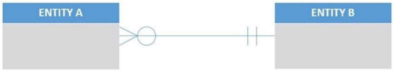
Which of the following is known to be true?
A) A single instance of ENTITY A must be related to many instances of ENTITY B.
B) The degree of the relationship is "many."
C) There are more instances of ENTITY A than there are instances of ENTITY B in the user's environment.
D) ENTITY A has a minimum cardinality of one.
E) A single instance of ENTITY B may be related to many instances of ENTITY A.

27) Given the tables

TABLE_A (Attribute1, Attribute2, Attribute3) TABLE_B (Attribute4, Attribute5, Attribute6)

as shown in the figure below, which of the following would display the correct placement of foreign keys in the relational model?

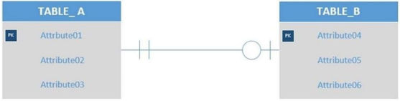
A) TABLE _A (Attribute1, Attribute2, Attribute3, Attribute6) TABLE _B (Attribute4, Attribute5, Attribute6)
B) TABLE _A (Attribute1, Attribute2, Attribute3, Attribute4) TABLE _B (Attribute4, Attribute5, Attribute6, Attribute1)
C) TABLE _A (Attribute1, Attribute2, Attribute3) TABLE _B (Attribute4, Attribute5, Attribute6)
D) TABLE_A (Attribute1, Attribute2, Attribute3)
TABLE _B (Attribute4, Attribute5, Attribute6, Attribute1)
E) TABLE _A (Attribute1, Attribute2, Attribute3, Attribute4, Attribute5) TABLE _B (Attribute4, Attribute5, Attribute6)

28) In many-to-many relationships in a relational database design .
A) the key of the child is placed as a foreign key into the parent
B) the key of the parent is placed as a foreign key into the child
C) the keys of both tables are placed in a third table
D) the keys of both tables are joined into a composite key
E) Both C and D

29) What relationship pattern is illustrated in the following schema?

VEHICLE (VehicleID, Cost)
CAR (VehicleID, NumberOfSeats) TRUCK (VehicleID, CargoCapacity)

VehicleID in CAR must exist in VehicleID in VEHICLE VehicleID in TRUCK must exist in VehicleID in VEHICLE
A) Association relationship
B) Supertype/subtype relationship
C) Recursive relationship
D) Strong entity relationship
E) Intersection relationship

30) By default, when Microsoft Access creates a relationship between two tables, it creates a(n) .
A) 1:1 relationship
B) recursive relationship
C) association relationship
D) 1:N relationship
E) N:M relationship

31) The first step in transforming an extended E-R model into a relational database design is to .
A) document referential integrity constraints
B) create a table for each entity
C) evaluate the entities against the normalization criteria
D) remove any recursive relationships
E) create a table for each relationship

32) In a relational database design, all relationships are expressed by .
A) creating a subtype
B) creating a primary key
C) creating a foreign key
D) creating a line between entities
E) creating a supertype

33) What concurrent processing problem occurs when a transaction reads a changed record that has not been committed to the database?
A) Dirty reads
B) Serialized reads
C) Unlocked reads
D) Nonrepeatable reads
E) Phantom reads

34) Which type of lock assumes that no conflicts will occur?
A) Explicit locks
B) Granular locks
C) Shared locks
D) Optimistic locks
E) Open locks

35) The recovery technique in which the database is returned to a known state and then all valid transactions are reapplied to the database is known as .
A) transaction logging
B) rollforward
C) checkpointing
D) rollback
E) reprocessing

36) Preventing multiple applications from obtaining copies of the same record when the record is about to be changed is called ________..
A) block factoring
B) concurrent processing
C) serialized reading
D) lost updating
E) resource locking

37) Business Intelligence (BI) systems do which of the following?
A) Analyze current and past activities
B) Predict future events
C) Support routine operational activities
D) Both A and B
E) Record and process transactions

38) A Business Intelligence (BI) reporting system that uses extensions to SQL is .
A) RFM analysis
B) regression analysis
C) cluster analysis
D) OLAP
E) PHP

39) Which of the following is true about data mining applications?
A) They use sophisticated mathematical techniques.
B) They use sophisticated statistical techniques.
C) All data mining applications have many different users to support.
D) Both A and B
E) Their report delivery is more difficult than report delivery for reporting systems.

40) The term drill down means the user wants to .
A) sort data
B) get older data
C) aggregate data
D) summarize data
E) get more details

INSERT SCREEN CAPTURE OF “SQL QUIZ” (Step 2) HERE.

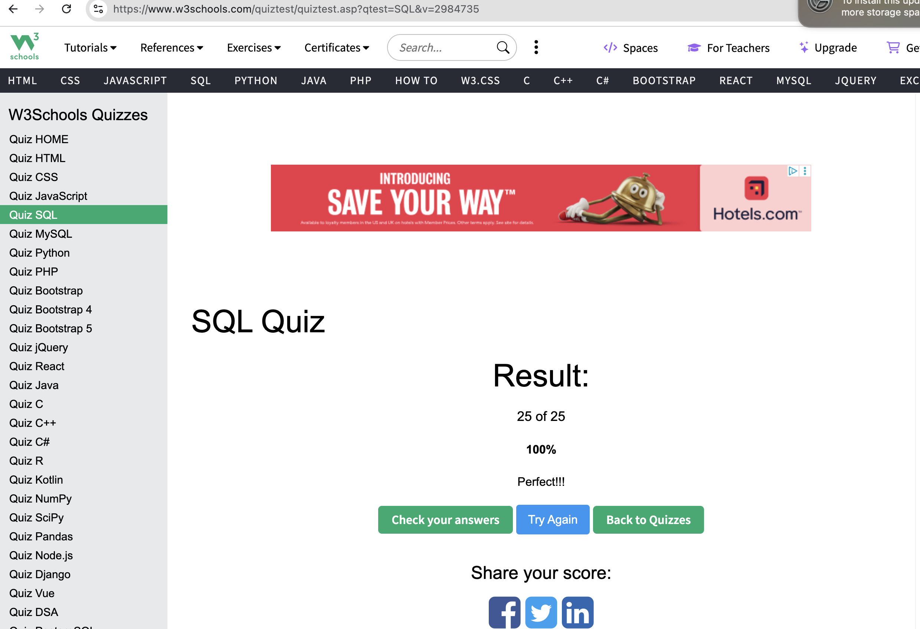

INSERT E-R Diagram (Step 3) HERE.

